Who murdered Macarena Valdés?
By Martín Cárdenas Llancaman
“It wasn´t suicide, it was murder” “We demand the Prosecutor´s Office to investigate the murder of Macarena Valdés. We demand the prosecutors to do their job”, said Ruben Collío before providing the results of a new autopsy in the Prosecutor´s Office. According to that evidence, Macarena Valdes, who was a Mapuche activist, didn´t commit suicide: she was murdered.
Macarena, mother to four children, was found hanged in her house located in an indigenous community on August 22nd, 2016. Ruben Collío, her husband, never trusted the results of the first autopsy, which asserted it was a suicide. Ruben and Macarena lived in Tranguil, Chile, a mountainous place where “RP Global”, an Austrian energy company, intends to set up a hydroelectric power station. Both opposed the project, they and other members of the community had claimed that the new power station was illegal. On August 21st, the company’s employees threatened Macarena´s neighbours: they stated that if Mr. Collio´s family was not removed from the place, they would be attacked. The next day Macarena was found dead. On August 23rd, a work crew of RP Global, accompanied by police officers, went to Tranguil to install high voltage wires.
NEED FOR A SECOND AUTOPSY
Since then, Ruben Collío, supported by other Mapuche communities, has claimed his wife was murdered because of their struggle against the company.
However, the Prosecutor´s Office disagreed with the suspicion and he even tried to close the investigation twice, despite having a clear fact of what seemed very irregular for Macarena´s family: the first autopsy was made by a forensic examiner who had claimed suicide on two cases which in the end were proved as murders. As a consequence, Mr. Collío had to pay out of his pocket, a private forensic expert to carry on with the discontinued investigation. After the difficulties, he was able to hire a prestigious forensic examiner, Dr Luis Ravanal.
A second autopsy, made by Mr. Ravanal, revealed the activist´s body was hanged after her death. The results of the new examination were delivered four weeks ago and according to the expert: “There are no signs showing that the body was hanged while she was yet alive. That provides clear evidence contradicting the official piece of information”. Because of that crucial evidence the investigation has been reopened in a superior level; the Regional Prosecutor´s Office has taken part, and the Mapuche community expects to know the truth about a third party being involved in the murder of Macarena Valdés.
RP GLOBAL AND ITS ILLEGAL POWER STATION
RP Global is a transnational energy company and its headquarters are located in Austria. In spite of having no legal authorization they started setting up the new hydroelectric power station in Tranquil. This specific place has been classified as a touristic protected area. According to the Chilean law, it´s not possible to build any project on this kind of area without an environmental impact evaluation made by SEA (an environmental State office appointed to that task). Although it was illegal, the SEA allowed RP Global to install its equipment without the required evaluation. It was then when Ruben Collío, Macarena Valdés and other members of the community raised queries about the illegal procedure. After presenting their evidence to the Regional Government, the Mapuche community made its first protest on August 1st, due to the social pressure, the regional authorities agreed to arrange a meeting with the community on August 19th: two days after that meeting the Collío family was threatened by employees of the company.
The case of Mrs. Valdés is not a unique case in the continent. A recent article published by The Guardian noted that “environmental defenders are being killed at the rate of almost four a week across the world”. Ana Piquer, Executive Officer of Amnesty International in Chile affirmed recently in an interview that “It´s the duty of the State to safeguard and protect defenders, also to investigate this kind of attacks. A proper investigation about Macarena Valdés´ death is crucial. It has to be an independent and impartial investigation”. Up to now the State has remained silent.
Poster claiming for justice in the case of Macarena Valdés
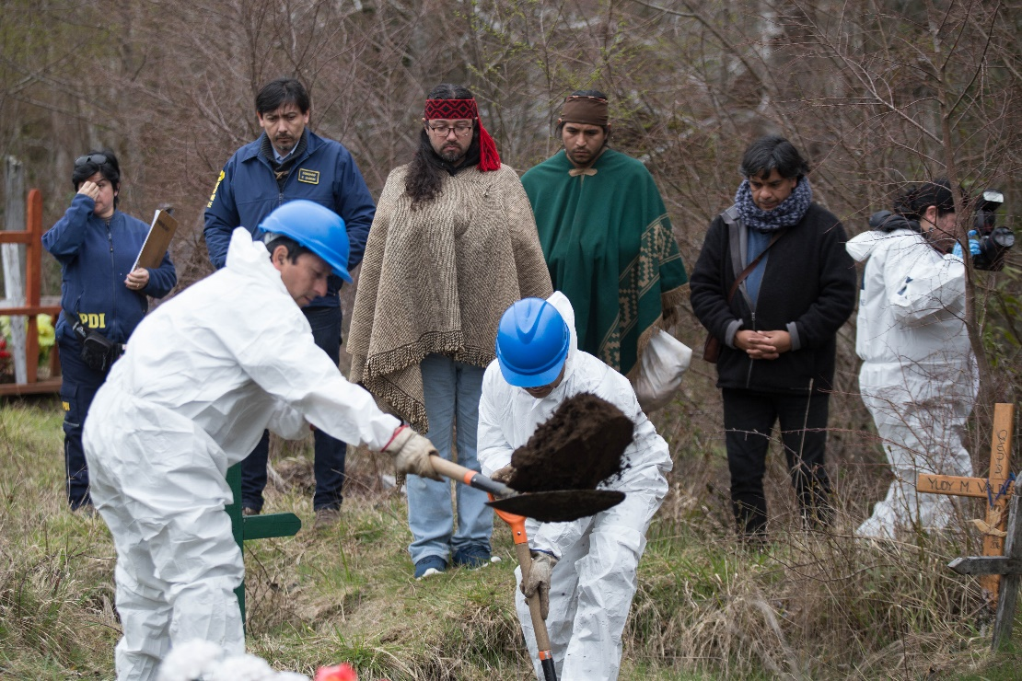
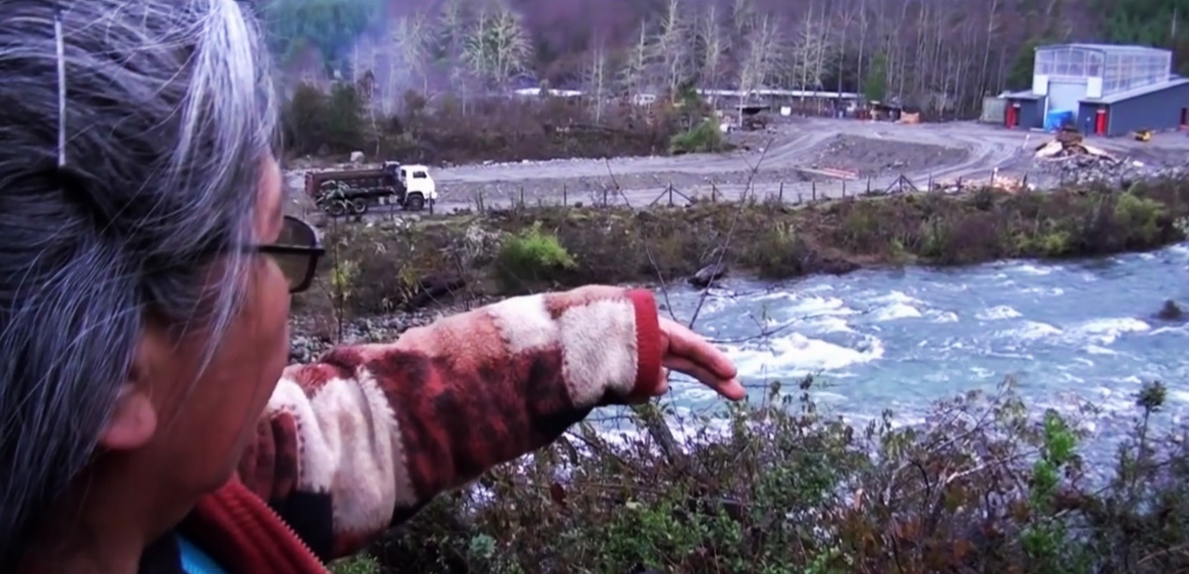
Exhumation of the body before the second autopsy
Tranguil River

